INSTRUCTOR GUIDE

Value Creation and Exchange Part 1: Understanding Utility & Value Propositions

Description and Learning Outcomes
Begin to investigate the value creation and exchange of your idea. This module will focus on understanding and communicating your value through utility and value proposition.

In this module, you will address the following questions:
- What is value creation and exchange?
- How can you develop product and service concepts with a focus on value and communicate that effectively?

By the end of this module, you will:
- Analyze products and services in order to break them down into their utility components
- Assess the value of a product or services from the perspective of a typical user

Other modules in the University of Toronto Scarborough The BRIDGE Entrepreneurship Open Learning Series include:
- Value Creation and Exchange Part 2
- Entrepreneurship Research 101 Part 1: Understanding Market Research Strategies
- Entrepreneurship Research 101 Part 2: Identifying and Finding Industry Research
- Self-Assessment: Are you an Entrepreneur?

Future modules include: Market Validation, Principles of Great Design, and Experiential Learning in Entrepreneurship.

Assessing Student Learning
The module includes a four reflective quizzes and three reflection exercises, below, that can be used in asynchronous learning.

Reflective Quizzes
If you are using this module in a course or workshop with a Learning Management System (LMS) consider using the LMS Quiz function for: participants to respond to the questions; and receive feedback on their responses, as they work to solidfy their learning.

Reflective Quiz #1: Categories of Utility Definition Quiz
Question: Match the term with its definition.

Term Choices:
- Form Utility
- Knowledge Utility
- Time Utility
- Place Utility
- Access Utility

Definition Choices:
- How does the shape and other ‘form factors’ of the product provide utility?
- A location for the purchase and/or consumption of the product or service adds ease, comfort or other utility.
- The availability and efficiency of access to the product or service connects favourably with consumers’ schedules.
- Used to be called ownership utility – describes the benefit of knowing a resource is available for your use when and where you want it.
- The readily available and understandable information that helps you to know how, when and why the product/service would be of use.

Answer:
Term | Definition
Form Utility | how does the shape and other ‘form factors’ of the product provide utility?
Place Utility | a location for the purchase and/or consumption of the product or service adds ease, comfort or other utility.
Time Utility | the availability and efficiency of access to the product or service connects favourably with consumers’ schedules.
Access Utility | used to be called ownership utility – describes the benefit of knowing a resource is available for your use when and where you want it
Knowledge Utility | the readily available and understandable information that helps you to know how, when and why the product/service would be of use.

Reflective Quiz #2: The Bakery’s Utility Multiple Choice Quiz
Question: Which categories of utility does the bakery business provide to customers in this example? (Check all that apply):
- Knowledge Utility
- Place Utility
- Time Utility
- Access Utility
- Form Utility

Answer: Knowledge Utility, Access Utility and Form Utility

Feedback:
- Knowledge Utility is provided because the bakery communicated the new delivery system in a novel way.
- Place Utility is not represented in this case.
- Time Utility is not represented in this case.
- Access Utility is provided as the bakery continued to provide access to their services while being COVID safe.
- Form Utility is provided as the bakery changed the delivery mechanism through the physical form of installing a service window.

Reflective Quiz #3: Utility and Value Definition Quiz
Question: Match the term with its definition.

Term Choices:
- Utility
- Value

Definition Choices:
- Objective, characteristics of product/service.
- Subjective, perc eptions would improve someone’s life.

Answer:
Term | Definition
Utility | Objective, characteristics of product/service.
Value | Subjective, perceptions would improve someone's life.

Reflective Quiz #4: Next Steps Reflection Quiz
Question: What next step(s) will you take? Check all that apply:
- Take other modules
- Contact your business librarian
- Explore more resources

Answer: No one correct answer. Response based on participants intended next steps.

Reflection Exercises
If you are using this module in a course or workshop with a Learning Management System (LMS) consider using the LMS Journal or Discussion Board feature for: participants to write their answers; to provide feedback to each participant’s responses; and to ask participants to come back to their answers, as they develop their business plans.

Reflection #1: Exploring Utility
Use your personal nitebook for this activity. This exercise will help you explore the inherent built-in utility of your own product or service.

Brainstorm: Think about your idea whether it’s a product or service.
- What is the inherent built-in utility?
- What are some subjective utilities?

Reflection #2: Examing Categories of Utility
Use your personal notebook for this activity. This exercise will help you examine categories of utility, their value and how the categories of utility might be designed to provide improved utility.

Step 1: Brainstorm
When someone visits their bank's website:
- What are the forms of utility that they might expect to receive?
- What value do you place on each one?
- Why?

Step 2: Analysis
Pick one of these forms of utility and explain how you might have designed it differently in order to provide more utility.

Consider: Is there a knowledge utility missing from the list? If so, why is it valuable to you and where would you rank it?

Reflection #3: Value Proposition – Function & Feel
Use your personal notebook for this activity. This exercise will help you examine the function of your own idea and feelings it may evoke.

Reflect Back: Review your response to Reflection #1 before completing this activity.

Brainstorm: Consider the function of your idea and the feelings it may evoke (or elaborate on the bakery as an example).
- How does this product/service make people feel?
- Considering the overall design of this product/service, is there an emotional experience or element to your product/service?

Assets

Reuse H5P Content
The modules use H5P, an open-source tool to create, share, and reuse interactive HTML5 content in your browser. To reuse this content, you may download the H5P file and use it where H5P content is created (Figure 1).

If you are part of an Ontario educational institution, you can create H5P content with the eCampus Ontario H5P Studio. Learn more about registering for a free account and start creating with the eCampus Ontario H5P Studio!

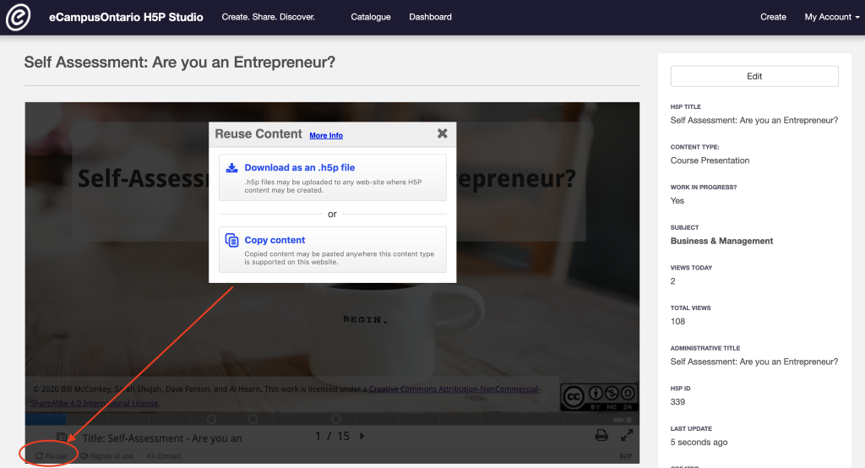
Figure 1: Go to the module and click on reuse in the bottom left corner to download or copy the content for reuse.

Embed in a Learning Management System (LMS)
You can embed the module directly into a Learning Management System using an embed code or iframe.
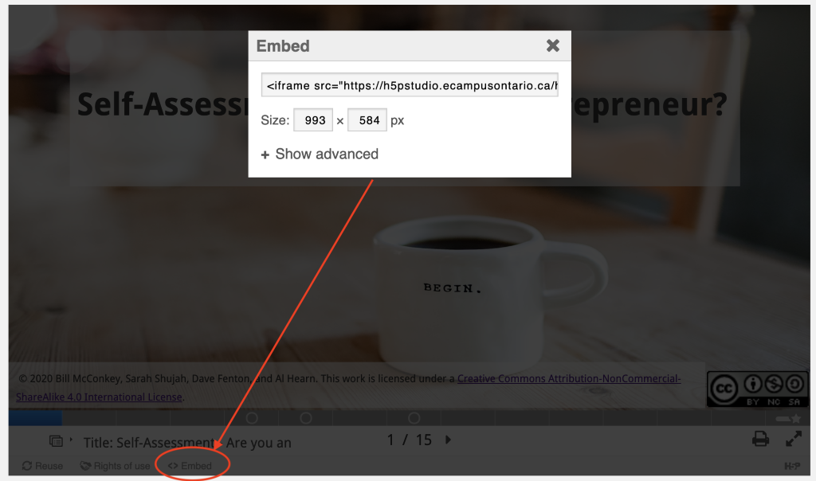
Figure 2: Go to the module and click on embed in the bottom left corner to copy the embed code or iframe that can be added to an LMS.

Slide Deck
Editable slide deck is provided as a separate PowerPoint file titled Slide deck Value Creation & Exchange Part 1 in Instructors Assets.

Video File
Video is provided as separate MP4 file titled Video file Value Creation & Exchange Part 1 in Instructors Assets.

Audio Captioning
Audio closed captioning is provided as a separate VTT file titled Transcript file Value Creation & Exchange Part 1 in Instructors Assets.

Rights of Use
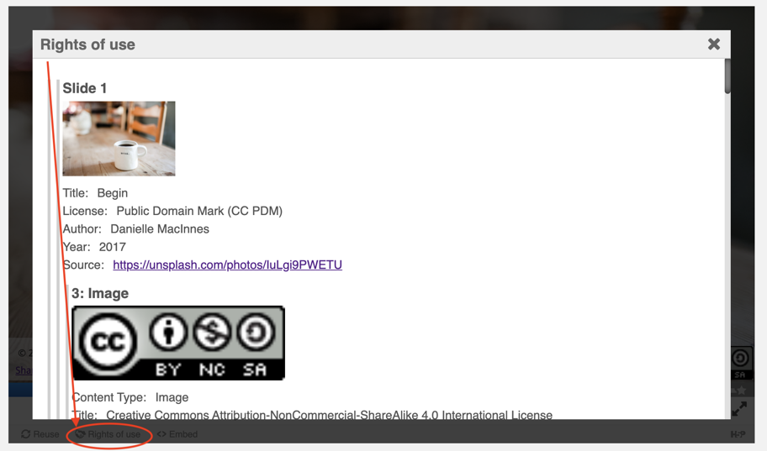
Figure 3: Go to the module and click on Rights of Use in the bottom left corner to find information on rights of use of images, figures, and graphs.

How do I give attribution?
If you are using, modifying, and/or distributing this resource you can cite/attribute and give credit to this resource by stating:

Value Creation & Exchange Part 1: Understanding Utility & Value Propositions, 2021, by Bill McConkey, Sarah Shujah, Danielle Moed, Al Hearn and Dave Fention available under a Creative Commons Attribution-NonCommercial-ShareAlike 4.0 International License.

If modifying or adapting then state:

This work is a modification of Value Creation & Exchange Part 1: Understanding Utility & Value Propositions, 2021, by Bill McConkey, Sarah Shujah, Danielle Moed, Al Hearn and Dave Fention available under a Creative Commons Attribution-NonCommercial-ShareAlike 4.0 International License.

