Adding Quizzical to your Course

- Click the “Settings” link in the Course Navigation.

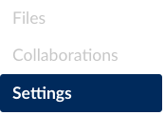
Figure 1 Settings Link
- Select the “Navigation” Tab.

Figure 2 Navigation Tab

- Scroll down to find "Quizzical".
Click the "More Options" button and select "Enable".
Click "Save".
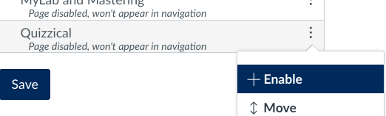
Figure 3 Enable Quizzical

- Confirm that "Quizzical" link is now available in the course navigation menu.

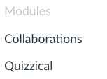
Figure 4 Quizzical in Course Navigation Menu

