INSTRUCTOR GUIDE
Self Assessment: Are you an Entrepreneur?
Description and Learning Outcomes
Are you entrepreneurial? What are characteristics of an entrepreneur?
In the first of a series of entrepreneurship skill building modules:
- You will be able to describe the traits of a typical entrepreneur.
- You will learn about the role of entrepreneurship in the Canadian economy.
- You will better understand your own entrepreneurship potential using the Business Development Bank of Canada (BDC) self-assessment survey.
Other modules in the series include Value Proposition Development, Market Validation, and Principles of Great Design.
Future modules include an introduction to entrepreneurship research, and experiential learning & entrepreneurship.

Assessing Student Learning
The module includes four reflection instances below that can be used in asynchronous learning.
If you are using this module in a course or workshop with a Learning Management System (LMS) consider using the LMS Journal or Discussion Board feature for participants to write their answers. Provide feedback to each participant responses. Ask participants to come back to their answers, as they develop their business plan.

Pre-Test Reflection
Do you think you are entrepreneurial? Yes or No?
Write down why or why not in your own journal.

Reflection #1: Are you a natural entrepreneur?
- In what situations do you get bored quickly?
- In what circumstances have you looked around and wondered how things could be done differently?
- In what situations are you good at completing things? When someone has told you to do something, what is your tendency to do it?
- Describe a situation in which you avoided a risky situation. Describe a situation in which you embraced a risky situation? What was driving you to act??

Reflection #2: BDC’s Entrepreneurial Potential Self-Assessment
After completing the Business Development Bank of Canada (BDC) assessment, write one paragraph that summarizes the most expected things and another paragraph describing the most surprising things that the survey suggests about you.

Reflection #3: What Resources and Capabilities Have You Developed?
- Describe an important skill that you gained from previous work experience. This could include leadership, project management, a key technical skill, interpersonal skills, relationship management or something else.
- Why do you think this skill is important?
- How have you applied this skill to solve a problem?
- What skills do you feel that you need to work on? Why?

Assets
Reuse H5P Content
The modules use H5P, an open source tool to create, share, and reuse interactive HTML5 content in your browser. To reuse this content you may download the H5P file and use it where H5P content is created (Figure 1).
If you are part of an Ontario educational institution, you can create H5P content with the eCampus Ontario H5P Studio. Learn more about registering for a free account and start creating with the eCampus Ontario H5P Studio!

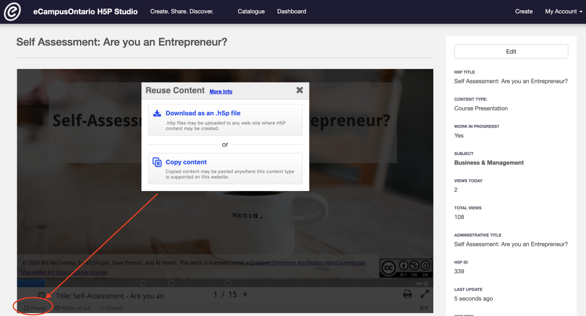
Figure 1: Go to the module and click on reuse in the bottom left corner to download or copy the content for reuse.

Embed in a Learning Management System (LMS)
You can embed the module directly into a Learning Management System using an embed code or iframe.
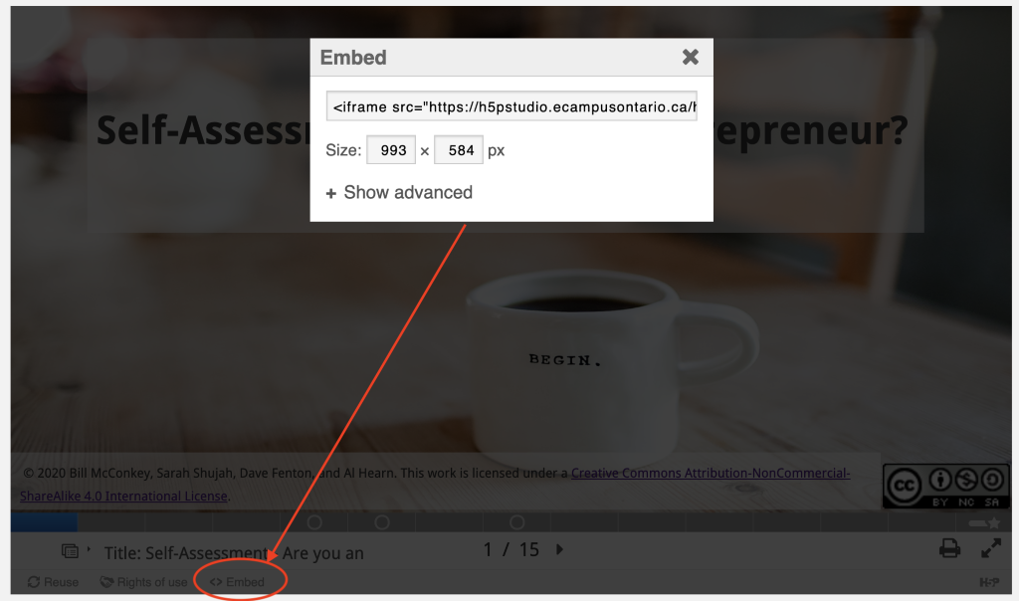
Figure 2: Go to the module and click on embed in the bottom left corner to copy the embed code or iframe that can be added to an LMS.

Audio Files
MP3 files for audio are provided as separate files in Instructors Assets.
Audio Captioning
Audio closed captioning is a separate Word document file included in Instructors Assets.

Rights of Use
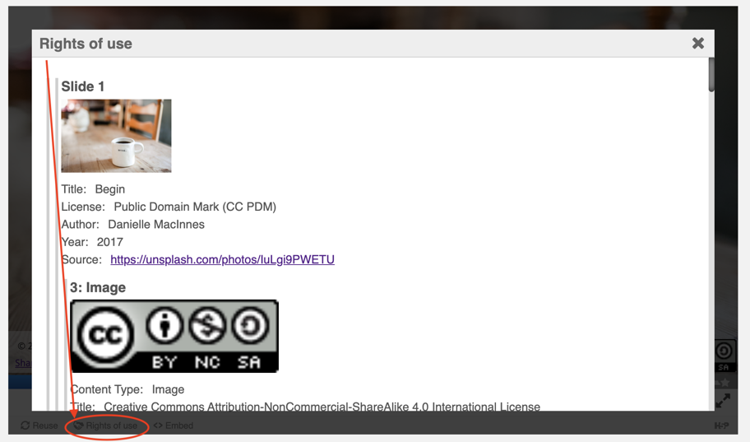
Figure 3: Go to the module and click on Rights of Use in the bottom left corner to find information on rights of use of images, figures, and graphs.
How do I give attribution?
If you are using, modifying, and/or distributing this resource you can cite/attribute and give credit to this resource by stating:
Self-Assessment: Are you an Entrepreneur? by 2020 Bill McConkey, Sarah Shujah, Dave Fenton, and Al Hearn available under a Creative Commons Attribution-NonCommercial-ShareAlike 4.0 International License.
If modifying or adapting then state:
This work is a modification of Self-Assessment: Are you an Entrepreneur? by 2020 Bill McConkey, Sarah Shujah, Dave Fenton, and Al Hearn available under a Creative Commons Attribution-NonCommercial-ShareAlike 4.0 International License.

