INSTRUCTOR GUIDE

Value Creation and Exchange Part 2: Knowing Your Target Market

Description and Learning Outcomes
Further investigate the value creation and exchange of your idea.

This module extends on the concepts introduced in Value Creation & Exchange Part 1 and focuses on knowing your your target market and how to communicate your value to them effectively.

In this module, you will address the following questions:
- What is your target market?
- How do you communicate the value with an understanding of who you market is?

By the end of this module, you will:
- Comparing the value of your offerings to those of your competitors
- Express the value of your product/service through compelling usage scenarios
- Assess opportunities for new products or markets

Other modules in the University of Toronto Scarborough The BRIDGE Entrepreneurship Open Learning Series include:
- Value Creation and Exchange Part 1
- Entrepreneurship Research 101 Part 1: Understanding Market Research Strategies
- Entrepreneurship Research 101 Part 2: Identifying and Finding Industry Research
- Self-Assessment: Are you an Entrepreneur?

Future modules include: Market Validation, Principles of Great Design, and Experiential Learning in Entrepreneurship.

Assessing Student Learning
The module includes a three reflective quizzes and three reflection exercises, below, that can be used in asynchronous learning.

Reflective Quizzes
If you are using this module in a course or workshop with a Learning Management System (LMS) consider using the LMS Quiz function for: participants to respond to the questions; and receive feedback on their responses, as they work to solidfy their learning.

Reflective Quiz #1: The Car Market Target Audience and Market Map Quiz
Question #1: When purchasing a BMW, what tradeoffs does the target market consider?
- Classy/distinctive and sporty
- Conservative and classy/distinctive
- Practical and sporty
- Practical and conservative

Answer: Classy/distinctive and sporty

Question #2: If the target market wanted a car that is conservative and practical, what care companies are they likely to consider in purchasing?
- Cadillac and Buick
- BMW and Pontiac
- Nissan and Toyota
- Dodge and Ford

Answer: Cadillac and Buick

Reflective Quiz #2: Benefits of Usage Scenarios Quiz
Question: Fill in the blanks with the missing words. Each blank contains one word only.

Answer: Correct responses are indicated by * symbol.
Developing usage scenarios helps with a number of things:
- Helping you to isolate and manifest the specific *value*
- Develops *language* that will be useful in promotions
- Let’s customers *visualize* their life with the product
- Serves to consolidate a *gap* between the consumer’s current (problematic) state and an *ideal* state
- and helps the consumer to see your product as a *solution* to this gap.

Reflective Quiz #3: Next Steps Reflection Quiz
Question: What next step(s) will you take? Check all that apply:
- Contact your business librarian
- Explore more resources
- Take other modules

Answer: No one correct answer. Response based on participants intended next steps.

Reflection Exercises
If you are using this module in a course or workshop with a Learning Management System (LMS) consider using the LMS Journal or Discussion Board feature for: participants to write their answers; to provide feedback to each participant’s responses; and to ask participants to come back to their answers, as they develop their business plans.

Reflection #1: Connecting to you Target Market
Write your responses in your notebook. This exercise will help you identify potential competitors and what changes you might make to better connect to your target market.
Remember: Recall concepts of utility in Part 1 of the Value Creation and Exchange module.

Step 1: Brainstorm
Imagine you run a professional sports team (think about a sport you enjoy). Outside of the other teams in your league, what are some competitors for you as a business?
Imagine next that you have been told that your revenues are down each of the last four years, even though sports and entertainment spending in your region has increased each year. What might some of the causes be? How would you go about determining these causes?

Step 2: Analyze
What changes to your ‘basket’ of utility might you consider making? How would you add to or change this basket of utility given the lockdown taking place due to COVID-19?

Reflection #2: Write a Usage Scenario
Write your response in your notebook.Consider the usage scenario example for the SHAKE. Write a usage scenario for the bakery during COVID-19 example from Part 1 of the module.

Step 1: Invent a prototypical user
- Bakery customer
- COVID-19 business restrictions
- Walk-up takeout window

Step 2: Unique Value
- Bakery customer sees the unique value of the bakery and how it will solve real issues they have in their lives

Step 3: Notice, understand and want/like
- Bakery customer NOTICES product
- UNDERSTANDS your product
- Leads to WANTING/LIKING

Reflection #3: Value Proposition – Function & Feel
This exercise will help you integrate the what, why, and how into your business plan.
Write your responses in your own notebook.
Consider your own business product/service, or the SHAKE, or bakery, or a common household product when completing this exercise.
Step 1: Brainstorm
- What is your hypothesis for your product/service?
- Why are you developing this idea?
- Why would potential customers care about this product?
- What is my usage scenario?
- Where do I have confidence gaps in this product/service?

Step 2: Analyze
How will you integrate these considerations (the why, the what, and confidence gaps) into your business plan?

Assets

Reuse H5P Content
The modules use H5P, an open-source tool to create, share, and reuse interactive HTML5 content in your browser. To reuse this content, you may download the H5P file and use it where H5P content is created (Figure 1).

If you are part of an Ontario educational institution, you can create H5P content with the eCampus Ontario H5P Studio. Learn more about registering for a free account and start creating with the eCampus Ontario H5P Studio!

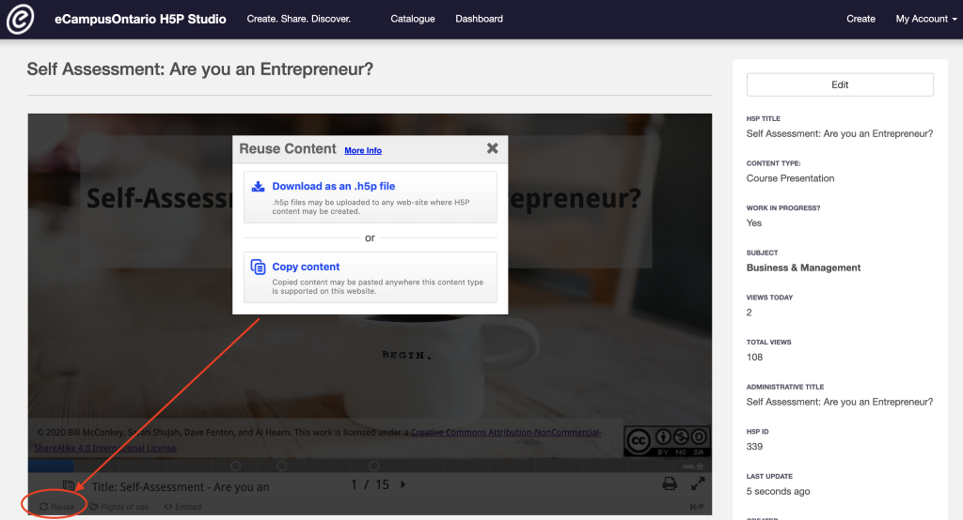
Figure 1: Go to the module and click on reuse in the bottom left corner to download or copy the content for reuse.

Embed in a Learning Management System (LMS)
You can embed the module directly into a Learning Management System using an embed code or iframe.
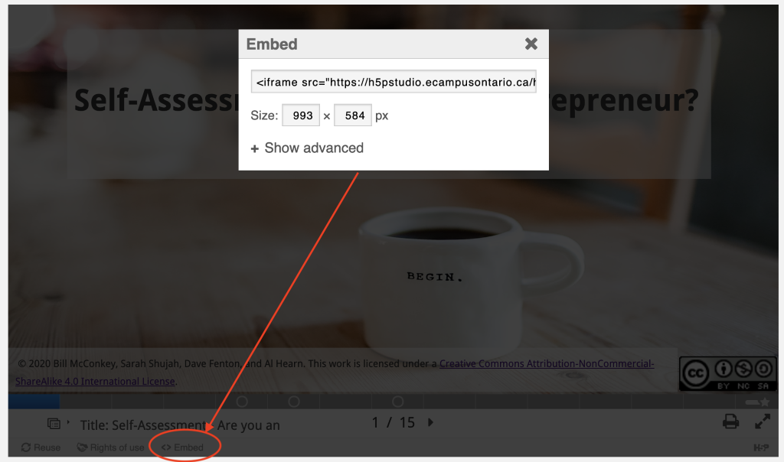
Figure 2: Go to the module and click on embed in the bottom left corner to copy the embed code or iframe that can be added to an LMS.

Slide Deck
Editable slide deck is provided as a separate PowerPoint file titled Slide deck Value Creation & Exchange Part 1 in Instructors Assets.

Video File
Video is provided as separate MP4 file titled Video file Value Creation & Exchange Part 1 in Instructors Assets.

Audio Captioning
Audio closed captioning is provided as a separate VTT file titled Transcript file Value Creation & Exchange Part 1 in Instructors Assets.

Rights of Use
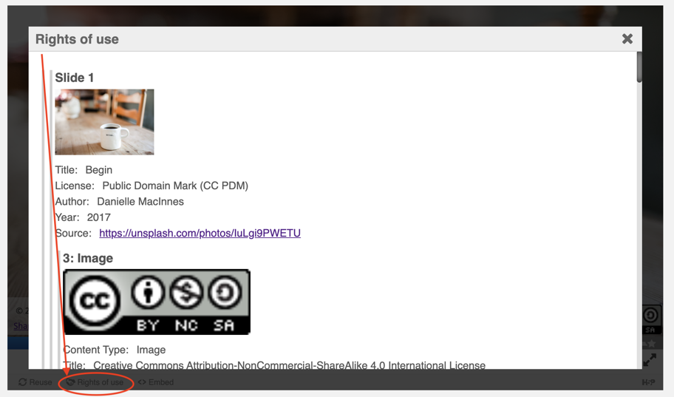
Figure 3: Go to the module and click on Rights of Use in the bottom left corner to find information on rights of use of images, figures, and graphs.

How do I give attribution?
If you are using, modifying, and/or distributing this resource you can cite/attribute and give credit to this resource by stating:

Value Creation & Exchange Part 1: Understanding Utility & Value Propositions, 2021, by Bill McConkey, Sarah Shujah, Danielle Moed, Al Hearn and Dave Fention available under a Creative Commons Attribution-NonCommercial-ShareAlike 4.0 International License.

If modifying or adapting then state:

This work is a modification of Value Creation & Exchange Part 1: Understanding Utility & Value Propositions, 2021, by Bill McConkey, Sarah Shujah, Danielle Moed, Al Hearn and Dave Fention available under a Creative Commons Attribution-NonCommercial-ShareAlike 4.0 International License.

