INSTRUCTOR GUIDE

Entrepreneurship Research 101 Part 2: Identifying and Finding Industry Research

Description and Learning Outcomes

Begin to investigate and find specific industries based on your needs.
This module will focus on secondary research tools and strategies that you can access openly online.
By the end of this module, you will:
- Have identified one or more industries for your business idea
- Apply the Resources & Capabilities Model to explore the industries’ utility gaps, resources and capabilities
- Take away a list of open resources to start your research

Other modules in the University of Toronto Scarborough The BRIDGE Entrepreneurship Open Learning Series include:
- Value Creation and Exchange Part 1
- Value Creation and Exchange Part 2
- Entrepreneurship Research 101 Part 1: Understanding Market Research Strategies
- Self-Assessment: Are you an Entrepreneur?

Assessing Student Learning

The module includes a two-part reflection exercise, below, that can be used in asynchronous learning. If you are using this module in a course or workshop with a Learning Management System (LMS) consider using the LMS Journal or Discussion Board feature for: participants to write their answers; to provide feedback to each participant’s responses; and to ask participants to come back to their answers, as they develop their business plans.

Reflection Quiz
Why do you want to do industry research? (Check all that apply):
- To understand challenges and growth potential of the industry/industries of my startup or business idea.
- To help with business planning and pitch prepartion.
- To identify my industry/industries of my startup or business idea.
Answer: No one correct answer. This is based on why participant want to do research.

Industry Types – Mark the Words Quiz
Select the terms that relate to industry types in the text below:
Industries are defined by the NAICS framework (see https://www.naics.com/search/).
Encore & Encore sells sustainable products including handbags. They operate in the retail industry and sell in a few markets for sustainble living
Answer: NAICS, retail

Market Segment Multiple Choice Quiz
- What are the different ways to segment a market?
  - Demographic, Perception, Socio-economic, Geographic
  - Geographic, Social, Pyschographic, Economic
  - Geographic, Psychographic, Demographic, Behavioural

Answer:
Geographic, Psychographic, Demographic, Behavioural

- What is the difference between industrial products and consumer products?
  - Industrial products - made by the industry
Consumer products - made by consumers
  - Industrial Products - end use is focused on creating other products
Consumer Products - end use is for consumers
  - Industrial Products - end use is for consumers
Consumer Products - end use is focused on creating other products

Answer:
Industrial Products - end use is focused on creating other products
Consumer Products - end use is for consumers

Reflection #1: Industry Keyword Brainstorming
Use Google Jamboard for this activity 10 minutes

Step 1:
Brainstorm possible industry keywords and competitors for your business idea in your personal journal or Jamboard. See an example for a fitness and diet tracker for Type 2 diabetics

Step 2:
To help, think about companies currently doing similar work and the industries they may be situated in. Use the “Find your industry” Canadian government website to help you brainstorm.
- Don’t worry if your industry keywords aren’t perfect! You will fine-tune them as you do your research.
- Other brainstorming tools include:
  - Lino
  - Padlet

Types of Assets Multiple Choice Quiz
- What are the different ways to describe the assets or resources & capabilities within your startup?
  - Physical, Reputational, Organizational, Financial, Intellectual, Technological
  - Profit, Respect, Outcomes, Finance, Interest, Technical
  - Physical, Reputational, Operations, Function, Intellectual, Technological
Answer: Physical, Reputational, Organizational, Financial, Intellectual, Technological

PROFIT: Does it pass the test? Fill in the Blank Quiz
Fill in the missing words
As you strive to create a sustainable competitive advantage, SOME of the PROFIT assets will need to meet the following test: ____, _____ , Hard to ____ , Hard to _____

Answer: valuable, rare, copy, substitute

Reflection #2: PROFIT & Utility
This exercise will help you to evaluate your company’s competitive position, and develop your business plan. Use the handout or personal journal
To help consider:
- the notion of ‘utility’, discussed in the Value Creation and Exchange module
- the R&C you defined through the PROFIT assets model.

- What utility gaps are you able to identify in the industry (processes, products, or services) related to your business idea?
- How can they be satisfied by the deployment of resources and capabilities that you have or can access?

Assets

Reuse H5P Content
The modules use H5P, an open-source tool to create, share, and reuse interactive HTML5 content in your browser. To reuse this content, you may download the H5P file and use it where H5P content is created (Figure 1).
If you are part of an Ontario educational institution, you can create H5P content with the eCampus Ontario H5P Studio. Learn more about registering for a free account and start creating with the eCampus Ontario H5P Studio!

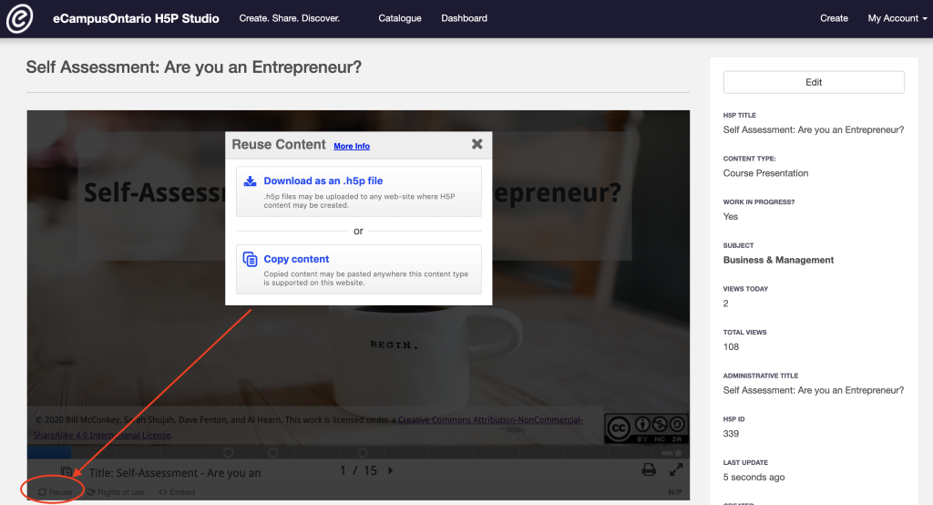
Figure 1: Go to the module and click on reuse in the bottom left corner to download or copy the content for reuse.

Embed in a Learning Management System (LMS)
You can embed the module directly into a Learning Management System using an embed code or iframe.
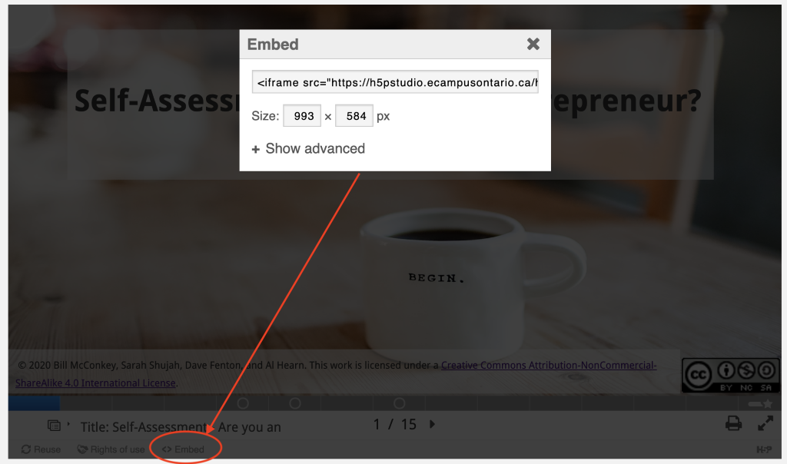
Figure 2: Go to the module and click on embed in the bottom left corner to copy the embed code or iframe that can be added to an LMS.

Video File
MP4 file for the video is provided as separate files in Instructors Assets.

Audio Captioning
Audio closed captioning is provided as a vtt document file that can be opened with a text editor. This is included in the Instructors Assets.

Rights of Use
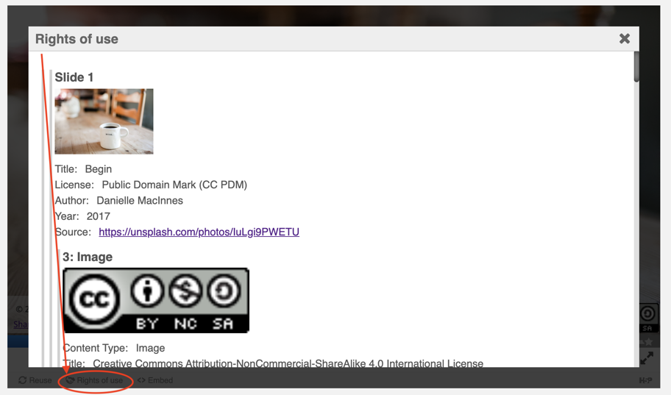
Figure 3: Go to the module and click on Rights of Use in the bottom left corner to find information on rights of use of images, figures, and graphs.

How do I give attribution?

If you are using, modifying, and/or distributing this resource you can cite/attribute and give credit to this resource by stating:
Entrepreneurship Research Part 2: Identifying and Finding Industry Research, 2021, by Sarah Shujah, Mariana Jardim, Carey Toane, Bill McConkey, Al Hearn, and Dave Fenton available under a Creative Commons Attribution-NonCommercial-ShareAlike 4.0 International License.

If modifying or adapting then state:

This work is a modification Entrepreneurship Research Part 2: Identifying and Finding Industry Research, 2021, by Sarah Shujah, Mariana Jardim, Carey Toane, Bill McConkey, Al Hearn, and Dave Fenton available under a Creative Commons Attribution-NonCommercial-ShareAlike 4.0 International License.

