INSTRUCTOR GUIDE

Entrepreneurship Research 101 Part 1: Understanding Market Research Strategies

Description and Learning Outcomes

What types of market strategies are used in entrepreneurship?
How does your product solve a problem or create new value for a user?

In this chapter in the series of entrepreneurship skill building modules you will:
- Be able to differentiate between primary and secondary market research.
- Have familiarized yourself with the various market research methods.
- Identify questions you want answered about your industry, customers and competitors.

Other modules in the series include: Self-Assessment: Are you an Entrepreneur?,
Value Creation & Exchange - Part 1 & 2, and Entrepreneurship Research 101 Part 1. You can access them from The BRIDGE website.

Assessing Student Learning

The module includes a two-part reflection exercise, below, that can be used in asynchronous learning.

If you are using this module in a course or workshop with a Learning Management System (LMS) consider using the LMS Journal or Discussion Board feature for: participants to write their answers; to provide feedback to each participant’s responses; and to ask participants to come back to their answers, as they develop their business plans.

In addition there is a drag and drop Quiz, a true/false quiz, and a multiple-choice quiz.

Reflection #1: Research Questions and Primary and Secondary Research

1. Individually or in your venture teams, based on your current hypothesis of your product, brainstorm a list of questions that you want answered for each of the following:
- your customers
- your industry
- your competitors

2. Identify those questions that you think can be answered through:
- secondary market research (mark with an 'S')
- Primary market research (mark with a 'P')

Primary and Secondary Research Drag and Drop Quiz
Drag the words and drop them in the box that best describe the research type it is referring to.

True and False Quiz
Qualitative research cannot be expressed in numerical form, can involve focus groups and target market interviews. Is this True or False?
Answer: True

Primary Research Strategies and Customer Development Quiz
Based on the video participants watch by Steve Blank, Getting Out of the Building. 2 Minutes to See Why

Blank, S. (2014, October 24). Getting Out of the Building. 2 Minutes to See Why [Video]. YouTube. https://youtu.be/TbMgWr1YVfs

- How did they ask questions to their customer segment to discover their product-market fit?
  - By discussing competitors
  - By discussing technical specifications of their product
  - By discussing value/utility
  - By discussing pricing
Answer: By discussing value/utility

- What did they discover by doing customer discovery using primary market research strategies?
  - Customers who value that utility
  - Elements of utility
  - Pricing model
  - All of the above
Answer: All of the above

Assets

Reuse H5P Content

The modules use H5P, an open-source tool to create, share, and reuse interactive HTML5 content in your browser. To reuse this content, you may download the H5P file and use it where H5P content is created (Figure 1).

If you are part of an Ontario educational institution, you can create H5P content with the eCampus Ontario H5P Studio. Learn more about registering for a free account and start creating with the eCampus Ontario H5P Studio!

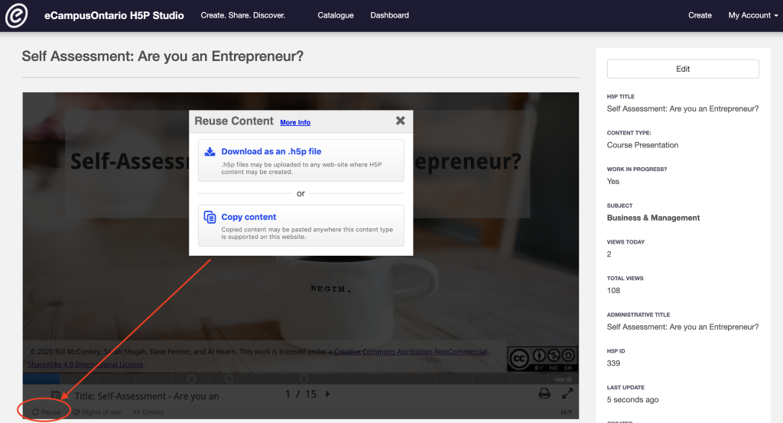
Figure 1: Go to the module and click on reuse in the bottom left corner to download or copy the content for reuse.

Embed in a Learning Management System (LMS)
You can embed the module directly into a Learning Management System using an embed code or iframe.
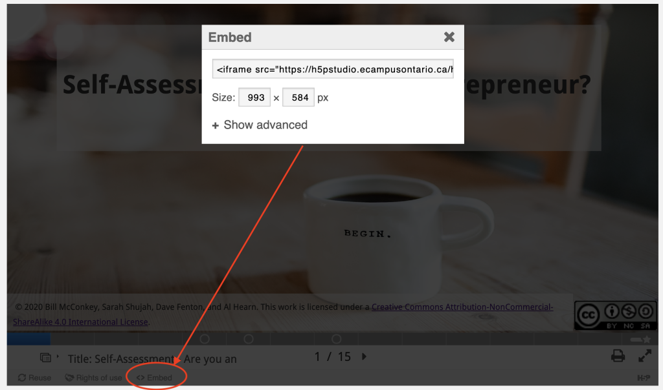
Figure 2: Go to the module and click on embed in the bottom left corner to copy the embed code or iframe that can be added to an LMS.

Video File
MP4 file for the video is provided as separate files in Instructors Assets.

Audio Captioning
Audio closed captioning is provided as a vtt document file that can be opened with a text editor. This is included in the Instructors Assets.

Rights of Use
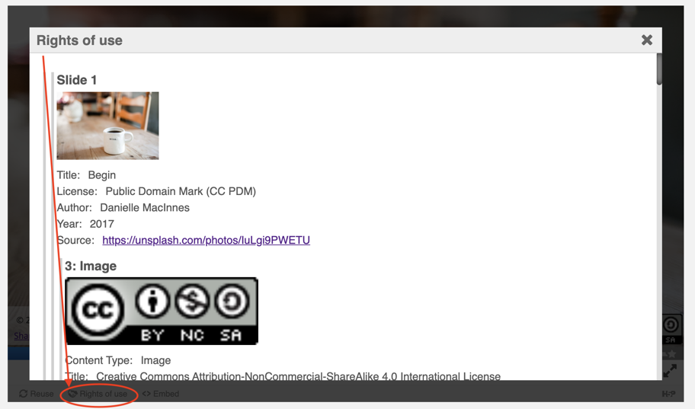
Figure 3: Go to the module and click on Rights of Use in the bottom left corner to find information on rights of use of images, figures, and graphs.

How do I give attribution?

If you are using, modifying, and/or distributing this resource you can cite/attribute and give credit to this resource by stating:
Entrepreneurship Research Part 1: Understanding Market Research Strategies, 2021, by Sarah Shujah, Mariana Jardim, Carey Toane, Bill McConkey, Al Hearn, and Dave Fenton available under a Creative Commons Attribution-NonCommercial-ShareAlike 4.0 International License.

If modifying or adapting then state:

This work is a modification of Entrepreneurship Research Part 1: Understanding Market Research Strategies, 2021, by Sarah Shujah, Mariana Jardim, Carey Toane, Bill McConkey, Al Hearn, and Dave Fenton available under a Creative Commons Attribution-NonCommercial-ShareAlike 4.0 International License.

